# JPA / Hibernate Project Description

Project Due 4/26 (Last Day of Class)

Teams are encouraged to submit earlier so that evaluations can be made and errors addressed by team before end of semester. Changes will not be made after semester’s end.

Drives will be returned the day of the final exam.

# Introduction

This project is a continuation of the JDBC project and demonstrates an alternative method of persisting objects using Java Persistence API and Hibernate.

# Deliverables

The version turned in on the due date is the final version. Only those portions that work correctly will receive credit as described in the following “Grading Criteria”. This policy is intended to encourage teams to finish well before the deadline and to verify the correct operation before final submission.

Each team will deliver their project on a USB thumb drive that contains the following material. Note that the drive will be returned.

* A completed template file: “JPA Project Evaluation – Team XX.docx” that includes contributing team member names and their Net-IDs, and the module they are responsible for completing. .
* A library jar file exported from your hibernateProjectForStudents project. This jar used by the instructor’s hibernateProjectTesting Eclipse project to execute the unit tests.
* The project’s source code. You can deliver the source code by the entire hibernateProjectForStudent project directory onto the USB thumb drive.

# Grading Criteria

Grades are awarded based on both team and individual contributions. The items marked in **green** will be evaluated on a team basis. The items marked in **red** describe the development of the three modules and will be evaluated on an individual bases.

1. **10 Points**. Providing a library JAR file from hibernateProjectForStudents that correctly compiles against the Eclipse project hibernateProjectTesting on the instructor’s personal Eclipse workspace. This will be accomplished by importing the submitted jar into the hibernateProjectTesting project build path.
2. **30 Points**. Executing the application PopulateTable.java and successfully populating the Customer, Address, CreditCard, Product, and Purchase tables created by Hibernate’s auto-generate option set in the persistence.xml configuration file.
3. **10 Points** is awarded on a team basis for the correct implementation of all three modules.
4. **40 Points**. Executing services unit tests provided in the hibernateProjectTesting packages *.unitTesting.service packages without error. See the section Service Modules.
5. **10 Points** for an evaluation of the quality of the design and code style.

# Entity Classes

The following classes represent the entities that will be persisted by the delivered services. Note that Java source files implementing these classes have been provided with the project materials. (hibernateProjectForStudent.zip)

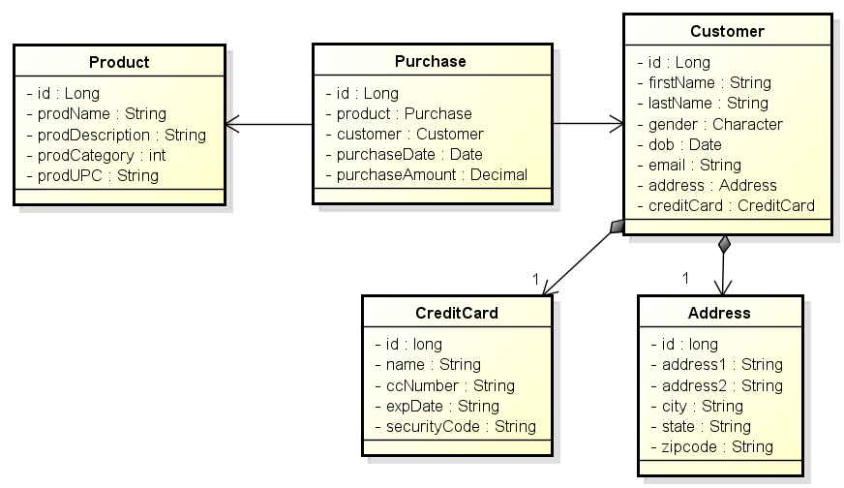

**Note**: Notice that the Purchase entity class maintains a reference to Customer and Product. The Purchase entity in the JDBC project maintained the Long ID value to the associated object for the sake of simplicity.

# Service Modules

In the interest of ensuring that each team member contributes to the development of the project, the implementation has been divided into three modules: Customer, Product, and Purchase. One or more team members is to be responsible for one of the three modules. The correct execution of all three modules will be evaluated on a team basis for 10 points.

The following illustrates the Service Module interfaces that will be delivered with the project. Each services implementation maintains an EntityManager.

The delivered classes must implement these interfaces for the grading / testing to execute correctly on an individual basis. Note that Java interfaces for these services have been provided with the project materials.

## Customer Persistence Module

The CustomerPersistenceService is responsible for managing the persistence of Customer, Address, and CreditCard entities.

This service is to be implemented so that every operation on a Customer also manipulates its associated Address and CreditCard instances. For example, retrieving a Customer though its ID, also returns the Customer’s Address and CreditCard. Deleting a Customer also removes its Address and CreditCard. Etc.

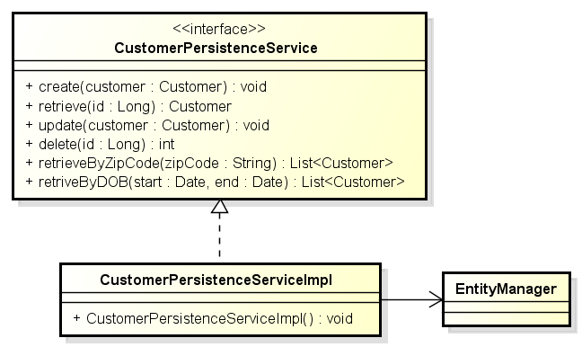

The CustomerPersistenceService provides the standard CRUD operation that allows the persistence and management of these instances. The service also provides operations that query for collections of Customer (Address & CreditCard) based on search criteria zip-code and date of birth ranges.

Notice that Address and CreditCard have not been provided persistence services in this design. This is because these are weak entities and attached to their Customer strong entity objects and all operations on a Customer are applied to their dependent Address & CreditCard objects.

## Product Persistence Module

The ProductPersistenceService provides the standard CRUD methods for Products maintained in the ecommerce sites inventory. The service also provides operations that allow for the query for Products in certain product categories and retrieving Products by their UPC (Universal Product Code).

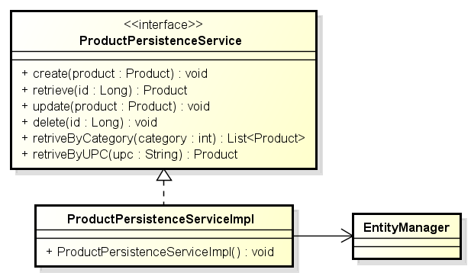

## Purchase Persistence Module

The PurchasePersistenceService provides the standard CRUD methods for Purchases made by Customers for Products. The services also allows for the retrieval of Purchases made by specific Customer, and for the retrieval of Purchases for specific Products. The service also provides a purchase summary of purchases made by specific customers.

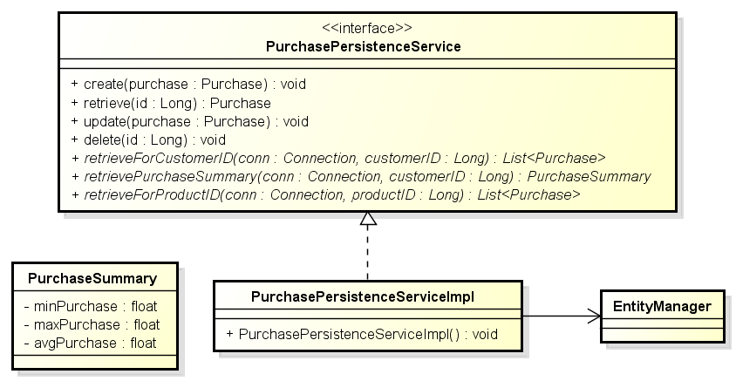

# Provided Materials

You have been provided two archived Eclipse projects (zip files) that will be imported into your Eclipse workspace. The last section of this document provides instruction on how the import is accomplished.

These projects are:

## hibernateProjectForStudents.zip

This project provides the basis for your Services implementations. This includes the Entity classes and Service interfaces as Java source. Your implementation will be written within this project, using these classes / definitions. The library jar file you create and submit for grading will be built from the work performed in this project.

**Do not change either the provided interfaces or the packaging structure. If changes are made, the unit tests will not compile (much less execute) and your team receives no credit for the work.**

## hibernateProjectTesting.zip

This project contains programs and unit tests that you will use to configure and test your service implementations.

**Except where noted in the source code, teams must not modify the code / contents of this project**. Changing the contents of the testing project will likely result in the unit tests in the instructor’s own unmodified testing project no longer working (no passing) and the loss of project points.

The hibernateProjectTesting project includes:

1. The application PopulateTables.java uses built-in JPA to both auto-generate the schema and populate the database generated by your team’s. This includes a number of CSV files containing the data used to populate the CUSTOMER, ADDRESS, CREDIT_CARD, etc. tables.
2. A number of Junit test classes that will test the correctness of your CustomerPersistenceService, PurchasePersistenceService, and ProductPersistenceService implementations.
3. The class PersistenceManager.java that is used to provide access to a singleton instance of a EntityManager used by the unit test classes. **Note**: The text file persistence.xml contains the DataSource configuration and must be updated with the parameters needed to access your MySQL installation. You must not modify the URL’s schema (simple_company).

## hibernateSampleCode2.zip

This project contains a working example of a Hibernate / JPA application that should provide a useful example of applying JPA to your simple company schema.

# Suggested Development Process

The following steps detail a suggested process for executing this project.

1. Import projects (Student, Testing, & Samples) into your Eclipse workspace.
2. Be sure that the Testing project’s Eclipse build path includes the Student project. You adjust the testing project’s build-path to include your hibernate project.
3. Annotate the five entity classes in the package cs4347.hibernateProject.ecomm.entity. These must be correctly annotated before the PopulateTable utility will work correctly in the following steps.
4. Using the MySQL workbench, manually create an empty schema “simple_company”. This is a schema with no tables. Although JPA will auto-generate the tables, JPA will not create the schema.
5. Use the program PopulateTables.java (provided in the Test project) to both generate the entity tables and populate these tables from the data contained in the CSV files. Note that the entity classes must be annotated for this step to work.
6. Verify that the tables have been created in simple_company and are populated with generally 100 rows each, although the Purchases table should contain 1000 rows.
7. Implement the interfaces CustomerPersistenceService, ProductPersistenceService, and PurchasePersistenceService. Note that the Student project has provided stubbed out implementation of the three interfaces. The
8. Use the provided service unit test (see the package *.unitTesting.service) to validate the correctness of your service implementations.
9. When all the tests work correctly, package ONLY the contents of the hibernateProjectForStudents project into a library jar file that will be submitted for grading. See the section “Exporting an Eclipse Project as a Library JAR File” at the end of this document.
10. Test that the library jar file works correctly by including the library jar in the hibernateProjectTesting project’s build path. NOTE: You will need to remove the project hibernateProjectForStudents from the testing project’s build path for the validation to work.

# Implementation Requirements

1. Note that your entity class ID annotations must include a GeneratedValue annotation with the annotation argument  
   **strategy = GenerationType.IDENTITY**. This will force the table to use an auto-increment key column. This restriction ensures that all of the tests that rely on known IDs will work correctly.
2. Except where noted in the source code, teams must not modify the code / contents of the Eclipse project hibernateProjectTesting. Doing so will likely result in the loss of points when the unit tests in the instructor’s own unmodified project no longer work.
3. The application DataSource will be configured with the contents of the property file ‘persistence.xml’ in the hibernateProjectTesting project. A property file has been provided with attaches to the DBMS running on the local machine. You will need to modify the id (maybe) and password. Do not change the default schema name (simple_company).

# Using Eclipse

## Executing Unit Tests in Eclipse

1. You may need to install the JUnit library on the testing project.
2. You can select individual JUnit test cases (Test Classes), right click, and select “Run As JUnit Test”. This can also be done on a package to run all the tests in the package or on the project to run all test cases in the project.

## Exporting an Eclipse Project as a Library JAR File

This section provides a procedure describing of how to export the project containing your team’s TaskExecutor implementation as a library .jar file for submission.

1. Select the project that you wish to export.
2. Use the right mouse button, or the file menu, to select the Export feature.
3. Select Java >>JAR File as shown below, and then Next.

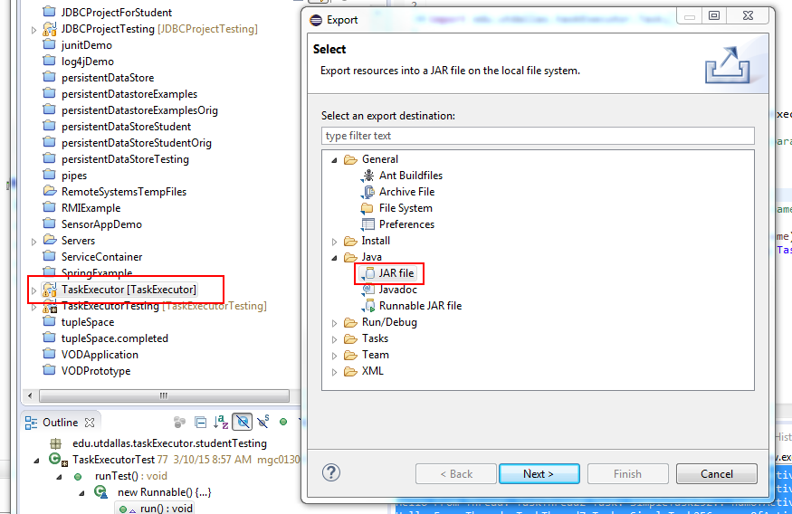

1. On the JAR Export panel, make sure that the desired project is selected and enter the path and file name for the exported library jar file.
2. Select Finish and the export operation will be completed.

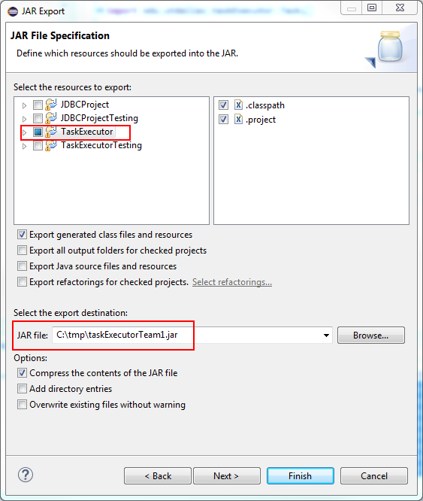

## Importing a Project into Eclipse from a Project Zip File

This programming assignment provides two exported projects that must be imported into your Eclipse workspace. These projects are provided as zip file archives that will be one of the files that can be downloaded from the WebCT assignment. The zip archive may contain sample code or a project template that can be used as a starting point for your efforts. You will be importing the project zip archive into your workspace.

**Optional: Removing existing projects with the same name from the workspace**

You cannot import a project with the same name into the workspace. This means that if you import and try to re-import the project template you must first delete the old project from the workspace. This is accomplished by selecting the existing project from the package explorer and selecting the “Edit > Delete” menu item. This will bring up the dialog shown in the following graphic. Notice that the option “Also Delete Contents Under C:\...” is selected**. It is very important that this option is selected** so that the project files are removed from you workspace

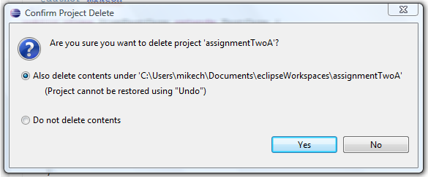

A this point the Old project will be have been removed from your workspace and you may begin importing the project template

## Importing the Project

The process for importing the template project is a follows.

Open the import wizard using the “File > Import” menu item. This brings up the import dialog shown in the following graphic. Make sure to select the “Existing Projects into Workspace” option (under General) and press Next.

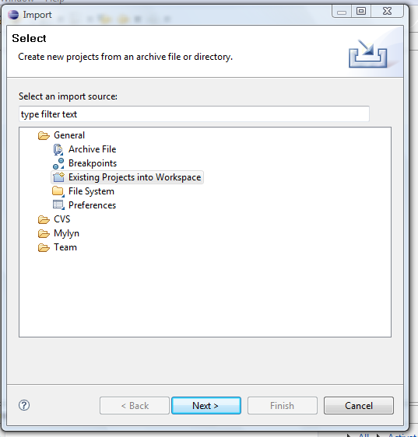

This brings up the following import dialog. There are a few import things to note:

1. You need to select the “Select archive file” option and then press browse to select the project template archive (zip) file.
2. When the file opens, you need to select the project.
3. Press Finish and the project will be imported into your workspace.

